**How to Iskip (Task) in EFMS**

**Step 1:** Run below query to check the status of the task in EFMS Database:

SQL>> select ord.usrp_order_number, wf.name, wf.status, wf.job_id, wf.task_id from ms_order ord, ms_sub_order sub, ms_job j, wf_task wf, wf_job job where wf.name in ('GIOM Tier Error') and ord.usrp_order_number in ('183262142') and ord.ms_order_id = sub.ms_order_id and ms_sub_order_id = j.entity_id and wf.job_id = hextoraw (j.wf_job_id) and wf.job_id = job.job_id and j.entity_type=5;

**Task Status**

-- 0 = Waiting

-- 1 = READY

-- 2 = ACQUIRED

-- 3 = Complete

-- 4 = Skipped

-- 5 = In-Progress

**Step 2a:** In below screen shot you will see task “GIOM Tier Error” status shows **1** is in Ready State, GO TO STEP 3:



**Step 2b:** If the status of the task is ‘4’ that is skipped then inform user that “**Task is already skipped in EFMS please check again**”:



**Step 2c:** If the task is in waiting status i.e. ‘0’

Display user that “**Task is not in ready status, kindly work on ready task to progress workflow”**.

**Step 2d:** If the task is in completed status i.e. ‘3’

Display user that “**Task is already completed in EFMS.”**

**Step 3:** I-Skip GIOM Tier Error task in EFMS.

Steps to Iskip the task:

* Login to asprd246 machine as prodsupp

/usr/localcw/bin/sudo su - m67007

/usr/localcw/bin/sudo su – prodsupp

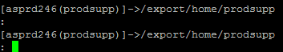

* Execute below script (Iskip) by changing Job_ID and Task_ID

/export/home/prodsupp/misprj/task.skip/./task.skip <**SPACE**> <JOB_ID><**SPACE**><TASK_ID>



/export/home/prodsupp/misprj/task.skip/./task.skip 02000017068E8CFA580B00010002038E 02000017068E8CFADF52000200020A36

* Enter the script under prodsupp and Hit Enter:



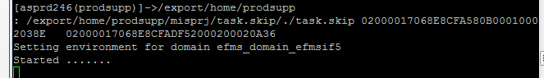

* Once script is finished, it will display you GIOM Tier Error is skipped successfully.

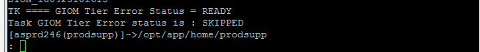

**Step 4:** Run the select query to check the status of the task in EFMS Database to make sure the task is skipped.

SQL>> select ord.usrp_order_number, wf.name, wf.status, wf.job_id, wf.task_id from ms_order ord, ms_sub_order sub, ms_job j, wf_task wf, wf_job job where wf.name in ('GIOM Tier Error') and ord.usrp_order_number in ('183262142') and ord.ms_order_id = sub.ms_order_id and ms_sub_order_id = j.entity_id and wf.job_id = hextoraw (j.wf_job_id) and wf.job_id = job.job_id and j.entity_type=5;

**Step 4a:** If task status is **4 or 3**: Display user that **“Task “GIOM Tier Error” for Order# XYZ is skipped in EFMS.**

**Step 4b:** If task status is **0 or 1**: Display user that “Task **“GIOM Tier Error” for Order# XYZ is NOT skipped in EFMS, Kindly contact EFMS BOA”.**